NAME: G. Yashmita REG NO: 192511032
EXPERIMENT 14:(Git/Github)
Demonstrate how to work collaboratively in Git/GitHub on a project
using the fork-and-pull request workflow.
Tasks:
1. Fork an existing public GitHub repository (e.g., a sample
JavaScript or Python project).
2. Clone the forked repository to your local machine using Git.
3. Create a new branch for the feature or change you want to
work on.
4. Make modifications or add new features (e.g., add a function,
fix a bug, or update the README).
5. Commit your changes and push the branch to GitHub.
6. Go to the GitHub repository and create a pull request to merge
your feature branch into the main branch.
7. Review the pull request and provide feedback on the changes.
8. Respond to feedback by making additional commits to the
feature branch if necessary.
9. Once the pull request is approved, merge it into the main
branch.
10. Finally submit the link to the pull request along with a
summary of the changes you made and how you collaborated.

Aim
To demonstrate collaborative software development using Git and GitHub through the Fork and Pull Request workflow.

Software Requirements
- Windows 10/11 or Linux/macOS
- Git
- GitHub Account
- Visual Studio Code
- Web Browser
- Internet Connection

Theory
Git is a version control system used to track changes in source code. GitHub is an online platform that hosts Git repositories and enables collaboration among developers.
The Fork and Pull Request workflow allows developers to contribute to a project without directly modifying the original repository. A developer first creates a fork of the repository, clones it to the local system, creates a separate feature branch, makes the required changes, commits and pushes the changes, and then creates a Pull Request for review. After the changes are reviewed and approved, the Pull Request is merged into the main branch.
This workflow helps maintain code quality, supports teamwork, and keeps project development organized.

Procedure

Step 1: Fork the Repository
- Open GitHub.
- Select a suitable public repository.
- Click the Fork option.
- Create a copy of the repository under the GitHub account.
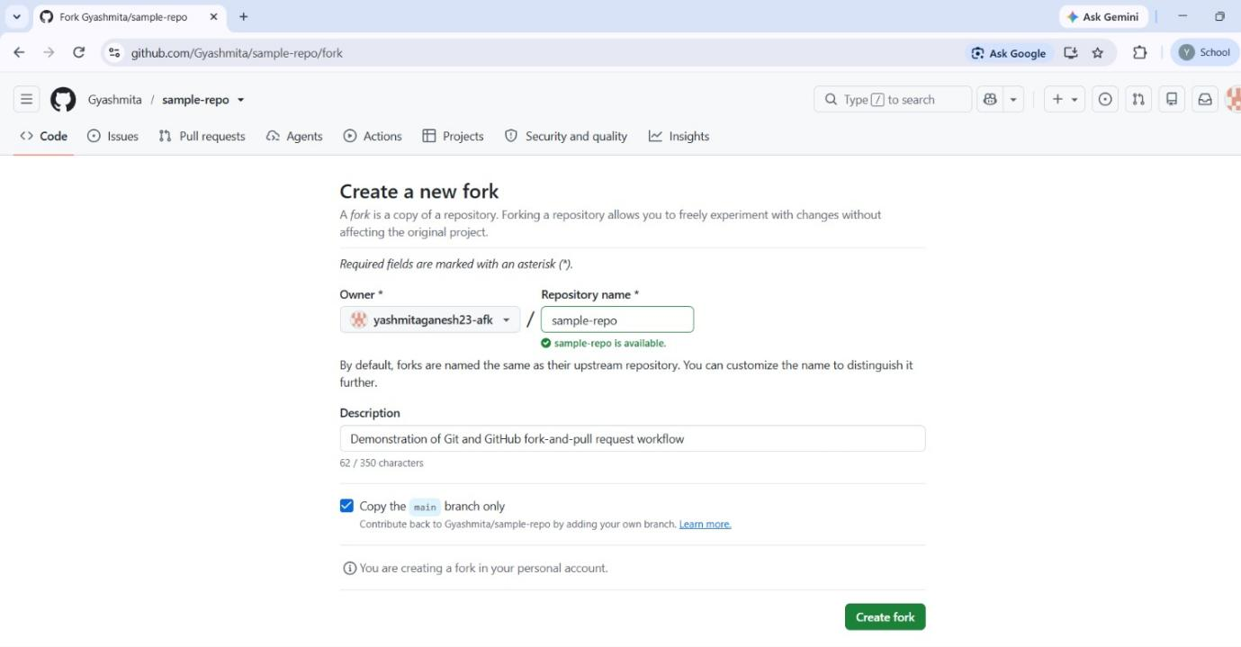

Step 2: Clone the Repository
- Open the VS Code terminal or Git Bash.
- Clone the forked repository using the following command:
git clone https://github.com/YourUsername/RepositoryName.git
- Move to the project directory:
cd RepositoryName
- Open the project in Visual Studio Code:
code .

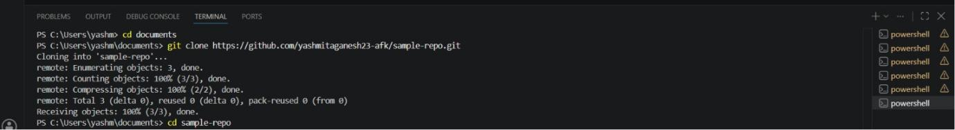

Step 3: Create a New Branch
Create a separate branch for the required feature or modification.
git checkout -b feature-updategit branch
The active branch is indicated by *.

Step 4: Make Changes
- Open the required project file in Visual Studio Code.
- Modify the file or add the required feature.
- Save the changes.
For this experiment, the README.md file was updated with information about Git/GitHub collaboration.
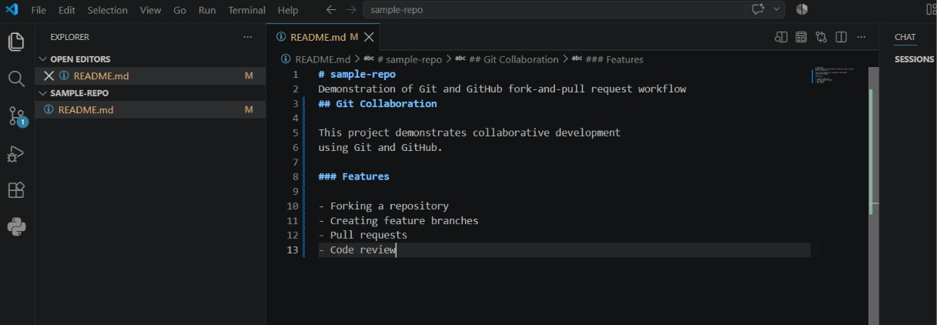

Step 5: Check the Status
Check the status of the working directory:
git status
This displays the modified and untracked files.

Step 6: Stage the Changes
Add the modified file to the staging area:
git add .
Verify the staged changes using:
git status

Step 7: Commit the Changes
Commit the staged changes with a meaningful commit message:
git commit -m "Update README with collaboration details"

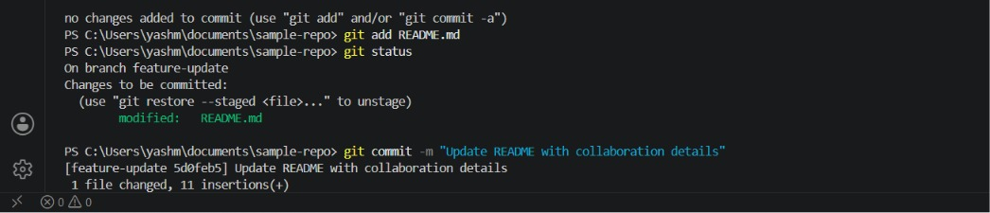

Step 8: Push the Branch
Push the feature branch to the remote GitHub repository:
git push origin feature-update
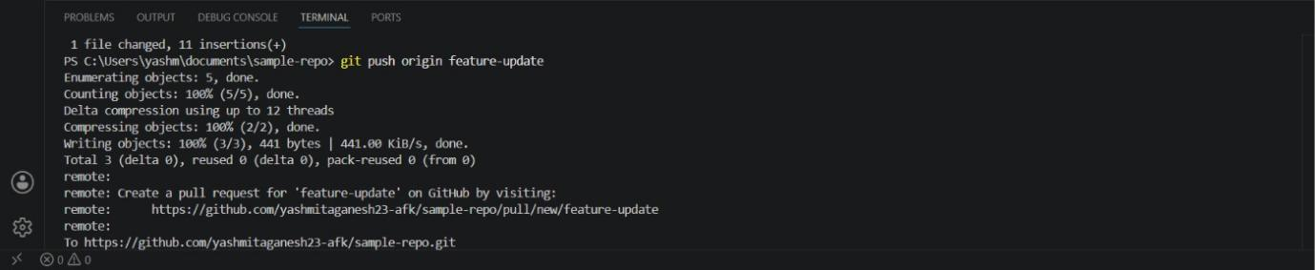
The feature branch is now available on GitHub.

Step 9: Create a Pull Request
- Open the forked repository on GitHub.
- Select the Pull Requests option.
- Click New Pull Request or Compare & Pull Request.
- Select the feature-update branch.
- Select the main branch as the base branch.
- Enter a suitable title and description.
- Click Create Pull Request.
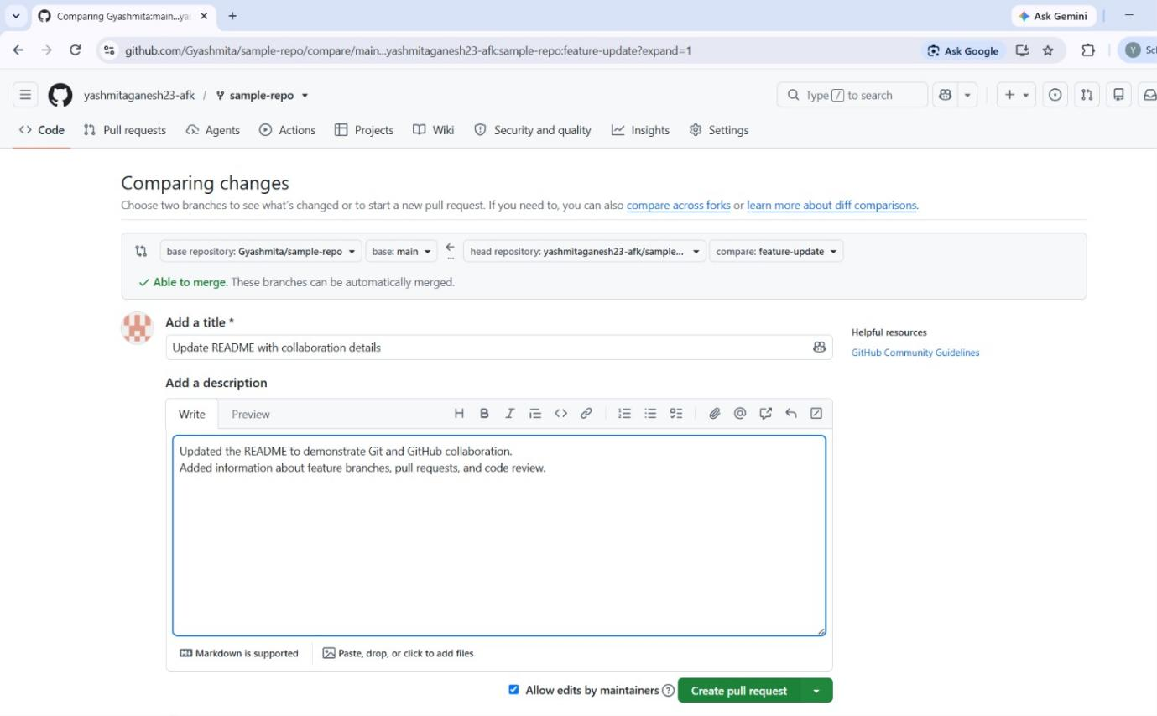

Step 10: Review the Pull Request
- Open the created Pull Request.
- Review the changes made in the feature branch.
- Check the modified files.
- Add comments or suggestions where required.
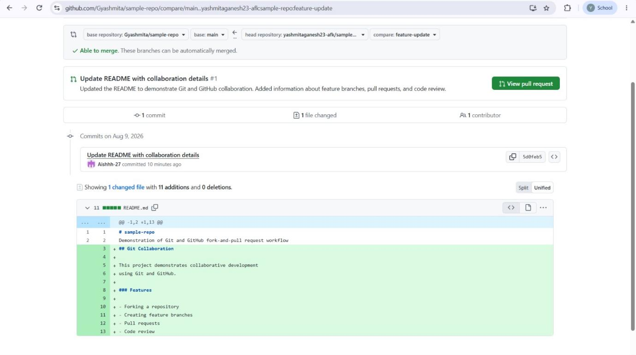

Step 11: Update the Pull Request
If changes are requested during review:
- Modify the required files.
- Save the changes.
- Stage the changes:
git add .
- Commit the changes:
git commit -m "Updated based on review"
- Push the changes:
git push origin feature-update
The new commit automatically updates the existing Pull Request.
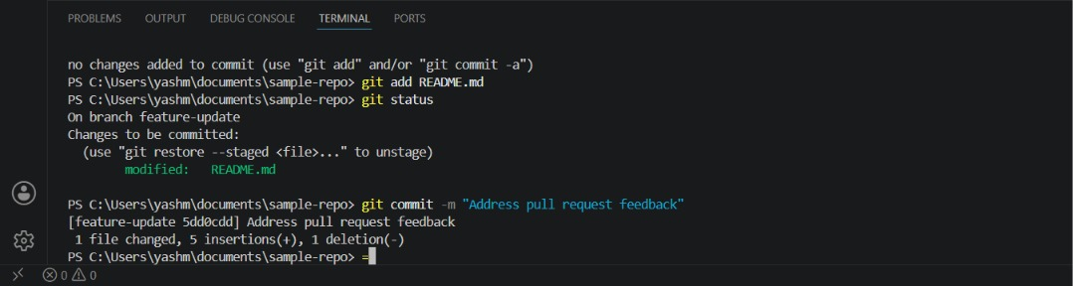
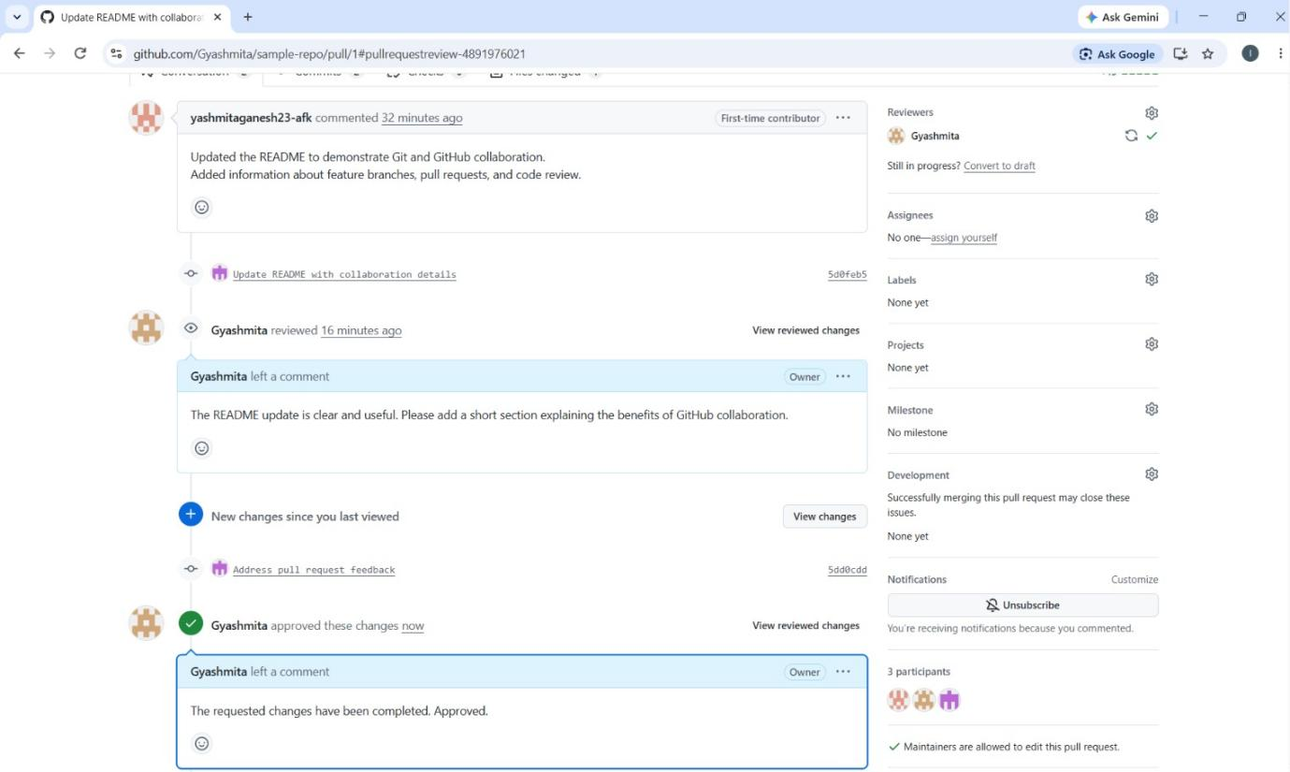
Step 12: Approve and Merge the Pull Request
- Review the updated Pull Request.
- Approve the changes after successful verification.
- Click Merge Pull Request.
- Click Confirm Merge.
- Verify that the Pull Request has been successfully merged into the main branch.
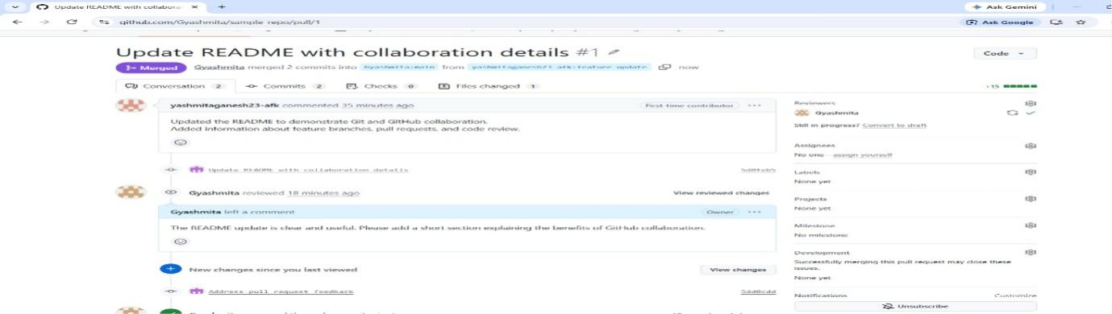

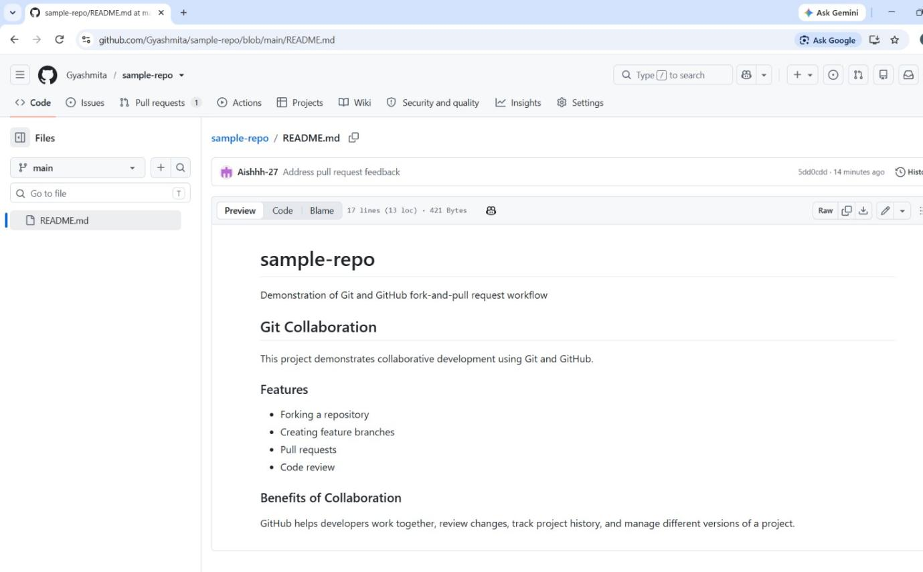

Result
The Git/GitHub Fork and Pull Request workflow was successfully demonstrated. Changes were developed in a separate feature branch, committed and pushed to GitHub, reviewed through a Pull Request, updated based on feedback, approved, and finally merged into the main branch.

